**“E-Recruit: An Online Recruitment System**

**for Insurance and Investment Agency**

**in Mindoro”**

A non-thesis Project

Presented to the Faculty of the

College of Computer Studies

**MINDORO STATE UNIVERSITY**

Calapan City Campus

Masipit, Calapan City, Oriental Mindoro

In Partial Fulfillment

of the Requirements for the Course of

**APPLICATION DEVELOPMENT AND EMERGING TECHNOLOGY**

Caibal, Lester M.

Escalera, Jandel L.

Ramos, Jef

BSIT III-F1

October 2023

**TABLE OF CONTENTS**

|  |  |  |  |
| --- | --- | --- | --- |
| **Chapter 1. Introduction** | | |  |
|  | **Project Context ……………………………………………………………………………** | | **1** |
|  | **Objectives …………………………………………………………………………………………** | | **3** |
|  | **Scope and Limitations ……………………………………………………………** | | **5** |
|  | **Definition of Terms …………………………………………………………………** | | **5** |
| **Chapter 2. Requirements Specification** | | |  |
|  | **Hardware and Software Requirements …………………………** | | **8** |
|  | **Functional Requirements ………………………………………………………** | | **10** |
|  | **Non-Functional Requirements ……………………………………………** | | **14** |
|  |  | Operational Requirement **………………………………………** | **14** |
|  |  | Performance Requirement **………………………………………** | **15** |
|  |  | Security Requirement **………………………………………………** | **16** |
| **Chapter 3. Design and Development Methodologies ………** | | |  |
|  | **System Design …………………………………………………………………………………** | |  |
|  |  | Database Design **……………………………………………………………** |  |
|  |  | Architectural Diagram/ Block Diagram **……** |  |
|  |  | DFD Level 0 **………………………………………………………………………** |  |
|  |  | UML Use-case Diagram **………………………………………………** |  |
|  |  | Sample Mock-up **………………………………………………………………** |  |
|  | **Agile Methodology ………………………………………………………………………** | |  |
|  | **Testing …………………………………………………………………………………………………** | |  |
|  | **ISO 25010 Evaluation ………………………………………………………………** | |  |
|  |  | Respondents Profile **…………………………………………………** |  |
|  |  | Likert Scale **……………………………………………………………………** |  |
|  |  | Evaluation Instrument **……………………………………………** |  |
|  |  |  |  |
|  |  |  |  |
|  |  |  |  |

**CHAPTER 1. INTRODUCTION**

In this chapter, researcher will delve into the essential aspects of the project that provide a comprehensive foundation for the project ahead.

**Project Context**

Digital technology is continuously evolving and reshaping industries. It has a huge impact on society because it influences the way people access information, communicate, and how people move in this society. As technologies are further developed, these issues also give rise to significant ethics and privacy concerns that need to be addressed. This is important because it enables a lot of things such as organizing, saving, and manipulating data in ways that will make work more efficient and effective. Digital Technology would surely prove to be a common asset in all professions, given the speed of technological development today.

The researchers are proposing the Online Recruitment System for Insurance and Investment Agents in Mindoro. This system will help to facilitate the hiring process for Agent’s applicants, it will help to make it easier to obtain and provide information because their traditional method will be replaced by a paperless transaction or Management system.

Recruitment management allows organizations to efficiently and effectively manage candidate/employee information, streamline the recruiting process, attract more qualified applicants, and adapt to modern recruitment strategies. It helps organizations create a niche for themselves by procuring talents without overshooting their budget and ensures proper placement, which improves employee morale. Recruitment management systems provide a robust toolset for reviewing, selecting, and sharing applicant information, screening applicants, managing duplicate candidates, and tracking candidate information. It also helps organizations reach out to young talent through social media (Obipi & Kalio, 2018).

A Recruitment Management System is important because it streamlines the recruitment process, saves time and effort for the HR team, improves collaboration and communication among the hiring team, enables data-driven decision making, and enhances the candidate experience. It automates tasks such as job posting, resume screening, and candidate tracking, making the recruitment process more efficient and organized. It also provides a centralized platform for team members to access and review candidate information, share feedback, and make informed decisions. Additionally, it collects and analyzes data on recruitment metrics, helping HR professionals identify areas for improvement and make data-backed hiring strategies. Lastly, it improves the candidate experience by allowing easy application tracking and timely updates (Edirisinghe, 2020).

**Objectives**

The study aims to develop and design an online recruitment system for insurance and investment agents in Mindoro, that will help the employer and applicants of Mindoro to make their transactions faster and easier. The main objective of this study is to improve the overall recruitment experience and become more accurate and efficient.

Specifically, this study is intended to:

1. Implement an online platform for agent applications that accepts electronic forms and signatures.
2. Create a thorough internet recruitment plan to interact and connect with potential agents in far-off places
3. Improve the agent hiring process by giving applicants easy access to online resources and support.
4. Reduce the cost that is associated with the traditional ways in recruiting new employees.
5. Make the hiring process more efficient by having to look on the applicant’s background without even meeting them personally.
6. Having a more efficient way of screening and interview scheduling through online.
7. Use the system to gather information of applicants to and analyze for better decision making.
8. Improve the experience of the applicant by providing them a user-friendly platform when applying.
9. Make a database of potential candidates for future openings.
10. Ensure the system follows the data protection and recruitment regulations.

**Scope and Limitations**

This study is limited to the aspects and factors of creating, designing, and implementing an Online Recruitment System for Insurance and Investment Agents. The proposed system will accommodate the transactions in recruiting agents only in Mindoro, Philippines. There are three users in the system; the admin, agents, and the applicants. The admin can add or register applicants, as well as the admin can use the system in recruitment, and then the agents can only access the recruitment system, Lastly, the applicants can view the requirements and input information about his/her background information, as well as the applicants can enter and edit information through the online platform using the system.

**Definition of Terms**

To facilitate comprehension and enhance clarity, researcher break down and explain the following terms:

**Metrics** - is a quantifiable measure used to assess and analyze the performance and effectiveness of the Online Recruitment System.

**Niche** - is the specific skill set or job market focus of the Online Recruitment System.

**Digital Technology** - is the utilization of electronic devices, software, and online resources to facilitate, and enhance various processes within the Online Recruitment System.

**Recruitment System** - is an integrated set of processes, tools, and technologies designed to manage and optimize the end-to-end recruitment and hiring process. It typically includes functionalities for posting job vacancies, collecting applications, screening candidates, and managing the overall hiring workflow.

**Overshooting** - is the situation where the number of applicants exceeds the available positions.

Toolset - is a collection of software tools and applications integrated into the Online Recruitment System to perform various tasks such as applicant tracking and evaluation.

**Social Media** - is utilized for postings, employer branding, and reaching potential applicants through platforms like Twitter, and Facebook.

**Data-Backed Hiring** - relies on the analysis of data and metrics to make informed decisions throughout the hiring process.

**Online Platform** - is a web-based interface or application that facilitates various recruitment activities, including application submission, communication between agents and applicants, and the management of the hiring workflow.

**Electronic Forms** - is a digital document that replace traditional paper-based forms in the recruitment process.

**Database** - is structured collection of data stored electronically, candidate profiles, and other relevant details.

**CHAPTER 2. REQUIREMENTS SPECIFICATION**

This chapter elucidates the specific criteria, features, and functionalities essential for the successful realization of our project.

**Hardware and Software Requirements**

**Software Requirements**

1. Visual Studio Code, ranging from version 1.70 to version 1.84, is a widely used and popular code editor.
2. CodeIgniter 4, specifically version 4.4.1, stands as a PHP web application framework for efficient web development.
3. Firefox or Google Chrome, both recognized web browsers, provide users with diverse options for internet browsing.
4. Windows 10 through Windows 11 represents a progression of different versions within the Windows operating system, catering to evolving user needs and system requirements.
5. Laragon version 6.0.0.0 is a Windows-based web development environment, streamlining the setup and management of web projects.
6. phpMyAdmin, at version 5.2.1, serves as a web-based tool designed for the efficient management of MySQL databases.

**Hardware Requirements**

1. For CPU and Memory, ensure ample RAM, with at least the 16GB RAM for efficient handling of anticipated loads.
2. For storage, prioritize SSDs for faster data access; consider 256GB SSD for storage.
3. For network infrastructure, integrate a dedicated 4G LTE modem to ensure reliable and high-speed internet connectivity for the network infrastructure.
4. Consider the Dell Latitude 5520 laptop with an Intel Core i5 processor, 16GB DDR4 RAM, 512GB SSD, a 15.6-inch FHD display, and 4G LTE capability for efficient and connected development.

**Functional Requirements**

**Administrator**

1. The system should allow the administrator to create an account and log in using registered credentials.
2. The system must enable the administrator to change the password by providing a 'Forgot Password' option.
3. The system must provide a comprehensive dashboard for the administrator, displaying crucial system statistics and key performance indicators.
4. The system should allow the administrator to view, manage, and access data for both agents and applicants, including the ability to edit, delete, and add new agent accounts.
5. The system should provide the administrator with an analytics section displaying an overview of the total number of agents, applicants, and other relevant recruitment data.
6. The system must enable the administrator to manage their profile details, including personal information and account settings.
7. The system should allow the administrator to download applicant forms and other relevant documents as PDF files for record-keeping and offline access.
8. The system should have facilitated communication between the administrator, applicants, and agents through an integrated messaging system within the platform.
9. The system should have a notification system to alert the administrator of any new messages, incoming applicants, or other relevant system activities.
10. The system must provide the administrator with a robust search and filtering mechanism to locate specific information about agents and applicants quickly.

**Agents**

1. The system should have a dedicated dashboard for the employees that displays the number of applicants they have recruited. This dashboard should include visually informative elements such as bar graphs or charts, illustrating recruitment metrics and performance data for easy interpretation and analysis.
2. The Agents/Employers must be able to log in using their given email and password by the administrator.
3. The system should have a facility where the agents and administrators could communicate, allowing agents to seek guidance and support when needed.
4. Agents should have the ability to securely view the data of applicants they have recruited, including personal information, application forms, uploaded documents, communication history, and application status.
5. The system should enable the agents to send messages directly so their recruited applicants through an integrated messaging system within the platform. This feature should allow for real-time communication and seamless interaction between agents and their recruits.
6. The system should enable the agents to manage their account details, including profile information, changing of passwords, and other relevant settings.

**Applicants**

1. The system should allow new applicants to create an account by providing necessary information like name, email address and password.
2. The applicants must be able to log in using their registered email and password.
3. The system must provide an online form for applicants to fill out personal and professional information, including contact details, work experience, education, and other relevant information.
4. The system should allow the applicant/s to upload the required documents and images such as resumes, identification, certificates, and other relevant files to support their application.
5. The system should enable applicants to save their work and return to the application later for modifications or updates before submission.
6. The system must incorporate a messaging feature that permits applicants to communicate with the system administrator or assigned agents regarding their application or any related queries.
7. The system must provide a submission mechanism that allows applicants to formally submit their completed application to the system.

**Non-Functional Requirements**

**Operational Requirement**

1. The system features an intuitive interface for applicants, catering to varying technical expertise levels, ensuring a seamless and user-friendly experience.
2. The system is compatible with desktops, laptops, tablets, and smartphones, ensuring applicants can access it on their preferred devices.
3. Robust error handling prevents incomplete or inaccurate submissions, maintaining data accuracy and application integrity.
4. The system is scalable to handle a large number of concurrent users during peak application periods without performance degradation.
5. Applicants can effortlessly upload relevant documents and images directly within the application process.
6. The system supports a user-friendly multi-step application process, allowing applicants to save progress and resume at their convenience.
7. The system adheres to data privacy regulations, ensuring secure handling of personal data throughout the application process.
8. Applicants have 24/7 access to the system, accommodating different time zones and enabling convenient submission at any time.

**Performance Requirement**

1. The system must respond to user actions (e.g., form submissions, document uploads) within 5 seconds to ensure a seamless application process.
2. Application pages and forms should load within 3 seconds to provide a smooth user experience and minimize the risk of applicant frustration or abandonment.
3. The system must handle a minimum of 500 concurrent users without a performance drop, ensuring all applicants can access and use the system concurrently.
4. The system should maintain 99.9% uptime, allowing for a maximum of 30 minutes downtime per month for maintenance or updates, ensuring continuous accessibility.
5. The system should enable the upload of images and documents, supporting a file size of up to 5MB, to prevent delays during the application submission process.
6. The system should retrieve applicant data within 3 seconds, enabling recruitment administrators to promptly access and assess candidate profiles and qualifications.

**Security Requirement**

1. Passwords are specifically encrypted using SHA-224 or SHA-256 from the SHA-2 family before storage in the directory, enhancing security and preventing unauthorized access.
2. The system strictly enforces role-based access control, ensuring that only designated personnel with specific roles can access and modify sensitive application data, minimizing the risk of unauthorized access.
3. Access to the database is meticulously controlled, with only authorized users granted specific permissions based on their roles.
4. Stored data in the database is encrypted, providing an additional layer of protection against unauthorized access and data breaches.
5. Routine security assessments are conducted to identify and address potential vulnerabilities, ensuring the ongoing integrity of the stored data.
6. The system performs regular and automated data backups, minimizing the risk of data loss and facilitating swift recovery in the event of system failures or cyber-attacks.

**CHAPTER 3. DESIGN AND DEVELOPMENT METHODOLOGIES**

In Chapter 3, researcher adopt the Agile Methodology to meticulously design and develop our system, integrating insights from related literature and detailing testing activities, ISO 25010 evaluation, and respondent profiles.

**System Design**

**Database Design**

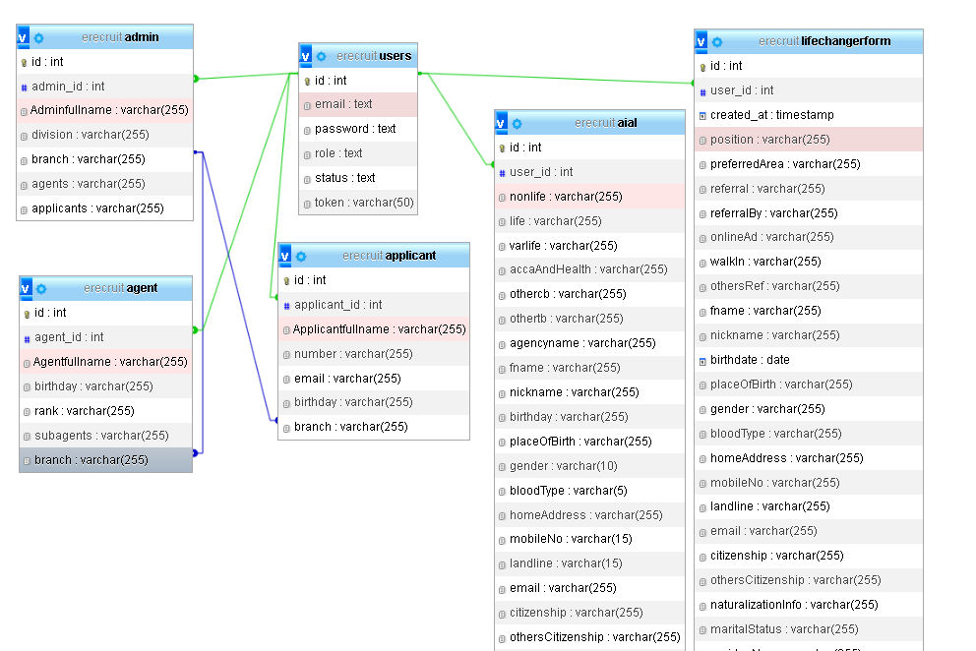

**Figure 1: Database Design**

Figure 1 encapsulates our commitment to efficiency, security, and user experience. It's not just a structure; it's a catalyst for success in every interaction, from administration to agent tasks and applicant engagement.

**Architectural Diagram/ Block Diagram**

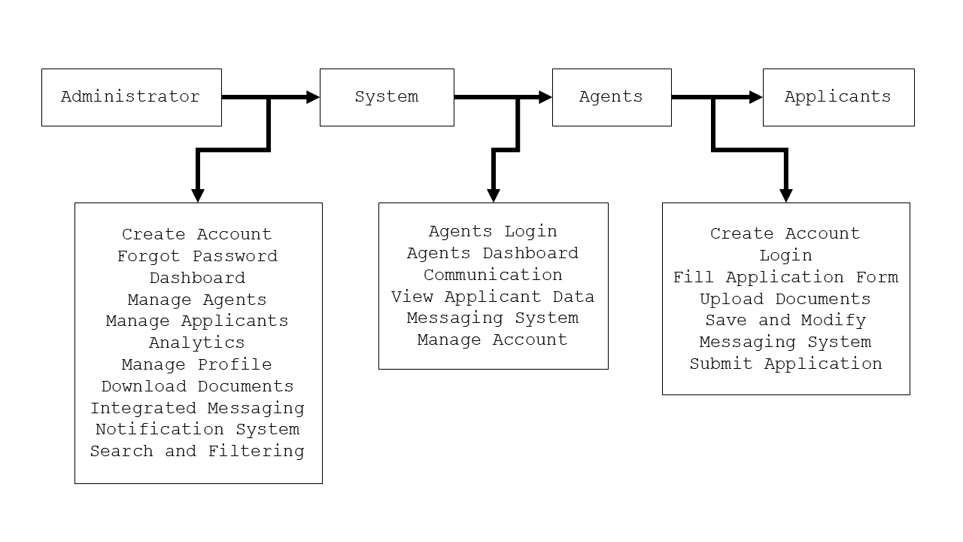

**Figure 2: Architectural Diagram**

This diagram illustrates the interaction between the three main entities: Administrator, Agents, and Applicants, along with the key functionalities described for each entity. The arrows indicate the flow of information and actions within the system.

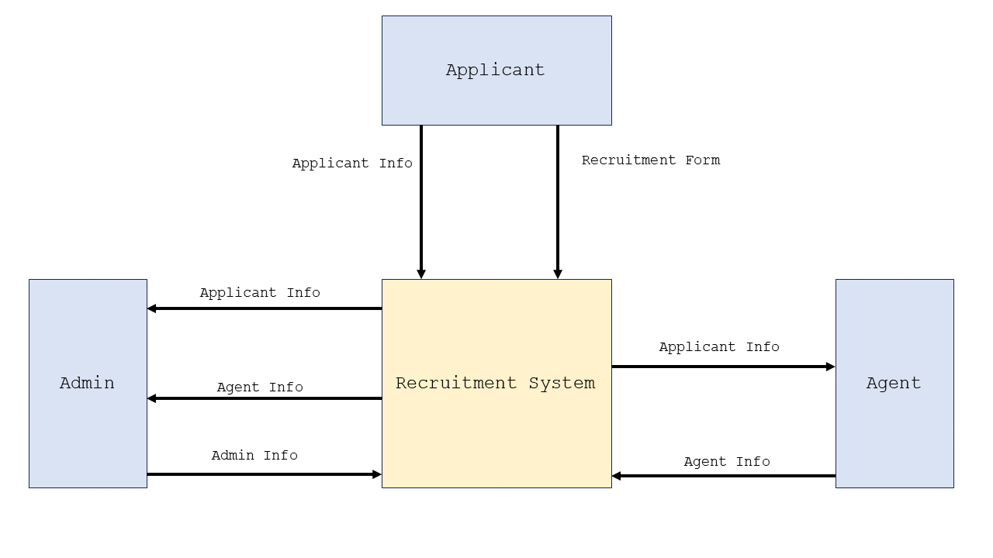**DFD Level 0**

**Figure 3: DFD Level 0**

Figure 3: DFD Level 0 illustrates the interactions and data flows between the Admin, Agents, and Applicants.

**UML Use-case Diagram**

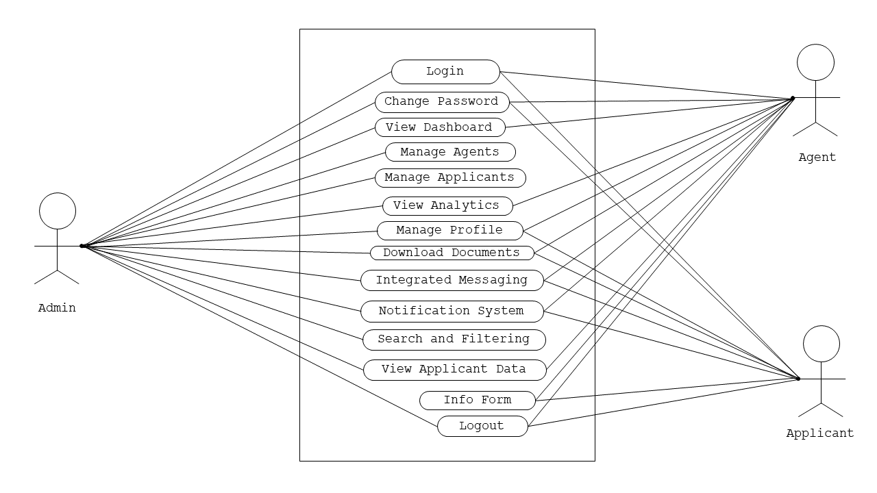

**Figure 4: UML Use-case Diagram**

This diagram provides a visual representation of the interactions between the system's actors (Administrator, Agents, and Applicants) and their respective use cases.

**Agile Methodology** - Agile method is chosen for this research, for the reason that it is really well-suited for developing the website for E-recruitment System. Each of which is necessary for an online hiring system to be successful and efficient. The effectiveness and efficiency of an online hiring system depend on its ability to adapt to changing needs and developing technology, which is why this strategy enables continuous improvements and adjustments. Agile's emphasis on customer input and collaboration further guarantees that the E-recruitment System will precisely match the needs and expectations of its users, which enhances the system's overall efficacy.

**Testing** - Indicate all the testing activities you performed and why it is being performed

**ISO 25010 Evaluation**

**Respondents Profile** - Explain how you chose your respondents then indicate their profile

**Likert Scale** - Indicate the Likert Scale and its verbal interpretation

**Evaluation Instrument**- Provide the instrument that you will use for evaluation

**REFERENCES**

Edirisinghe, S. M. (2020). *Recruitment Management System*. <https://dl.ucsc.cmb.ac.lk/jspui/bitstream/123456789/4486/1/2017%20MIT%20017.pdf>

Grace, M., Ventura, G., & Bringula, R. P. (2013). *Effectiveness of Online Job Recruitment System: Evidence from the University of the East*. www.IJCSI.org

Obipi , I. O., & Kalio, N. (2018). Recruitment Management System and Employee Procurement in the Oil and Gas Sector in Nigeria. *International Journal of Human Resource Management and Research*, *8*(2), 7–18. https://doi.org/10.24247/ijhrmrapr20182

Kmail, A. B., Maree, M., Belkhatir, M., & Alhashmi, S. M. (2016). An automatic online recruitment system based on exploiting multiple semantic resources and concept-relatedness measures. *Proceedings - International Conference on Tools with Artificial Intelligence, ICTAI*, *2016*-*January*, 620–627. https://doi.org/10.1109/ICTAI.2015.95

Ramadhani, F., & Zarlis, M. (n.d.). *Analysis of e-Recruitment System Design*. https://doi.org/10.17706/ijeeee.2019.9.1.38-45

Rosoiu, O., & Popescu, C. (n.d.). *E-recruiting Platforms: Features that Influence the Efficiency of Online Recruitment Systems*. https://doi.org/10.12948/issn14531305/20.2.2016.05

Samoli, C. (2021, May 20). *How management systems drive value in business operations*. Monday.com Blog. https://monday.com/blog/project-management/management-systems/

Sehgal, V. K., Jagtiani, A., Shah, M., Sharma, A., Jaiswal, A., & Mehta, D. (2014). Job portal-A web application for geographically distributed multiple clients. *Proceedings - 1st International Conference on Artificial Intelligence, Modelling and Simulation, AIMS 2013*, 199–204. https://doi.org/10.1109/AIMS.2013.38

|  |
| --- |
| **Checked and Reviewed by:** |
|  |
| **Mr. Christian I. Cabrera** |
| **ITC311 - Facilitator** |